Milankovitch Cycles

Jonathon Sevy || BYU Fall 2021

# Introduction

Milankovitch cycles have dominated the global climate for at least the last several million years. These cycles are very important to understanding climate, however looking at paleoclimate data across the world is very difficult to correlate together due to differing response times, among other factors. Additionally, extracting data from multiple overlapping is important to calculating periodicity, strength of the cycle. Figure 1 shows the paleoclimate proxy δO18 as a temperature proxy and calculated solar insolation at 65°N latitude. Although both graphs show a clear cyclicity it is evident that it would be hard to pull quantifiable evidence out of the graph of either of them, and even harder to relate the two together by just graphing them. Using MATLAB two functions were created that could produce useful and quantitative information about time series and cyclicity in data.

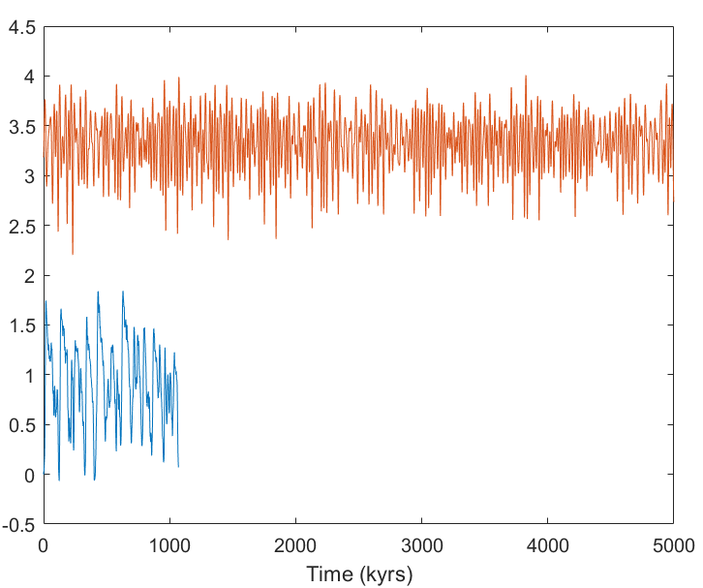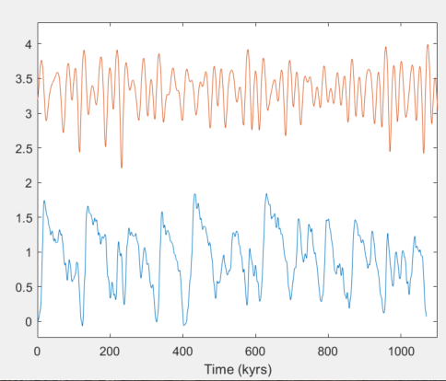

# Methods

To better understand the cyclicity in time series data two MATLAB functions were created, “mlvcy1” and “mlvcy2”. These functions can be used to both analyze a timeseries dataset, but also compare two related timeseries datasets. The analysis here is with regard to calculated insolation data and oxygen isotope data from foraminifera, but the same processes can be used to analyze other types of temperature, or time series data.

The mlvcy1 does auto spectral analysis, of the chosen dataset. This will do one of two analyses based on user specified input. The first option is called a Blackman-Tukey auto spectral analysis, which outputs a power spectrum using discrete Fourier transform to output the frequency (inverse of the period) and the power, or strength, of the oscillation at that frequency. The second option is a wavelet spectral analysis. Wavelet spectral analysis uses a package of a decreasing wave that can be stretched and translated in both frequency and time. Wavelet analysis produces a matrix of power at a given time and frequency, allowing to map changes in strength of cyclicity over time.

The mlvcy2 program does cross spectral analysis of two related time series data sets. Mlvcy2 will find the cross spectrum peaks, and associated coherence (similar to persons R squared correlation), phase angle. This will also calculate the response time the between the two cycles. This allows for better comparison between two datasets that may be taken at diferent parts of the world that would have reacted at different times to Milankovitch, or other forcing. Cross spectral analysis allows for better use of global time series data. In order for this to work only time series that have similar times can be analyzed. The program will look for and only use the period of time which both time series have in common.

Figure 2. Blackman-Tukey autospectral analysis of calculated insolation data (left) and marine δO18 data (right). Shows power, or strength of cycle, and the frequency which is the inverse of the period.

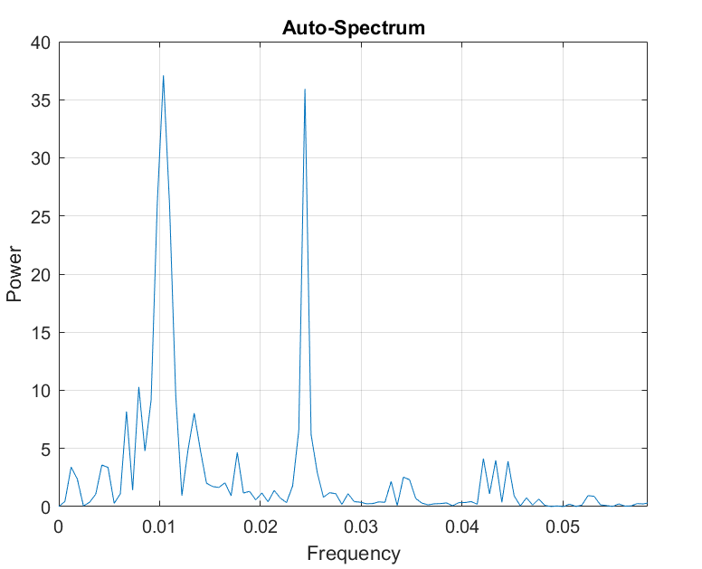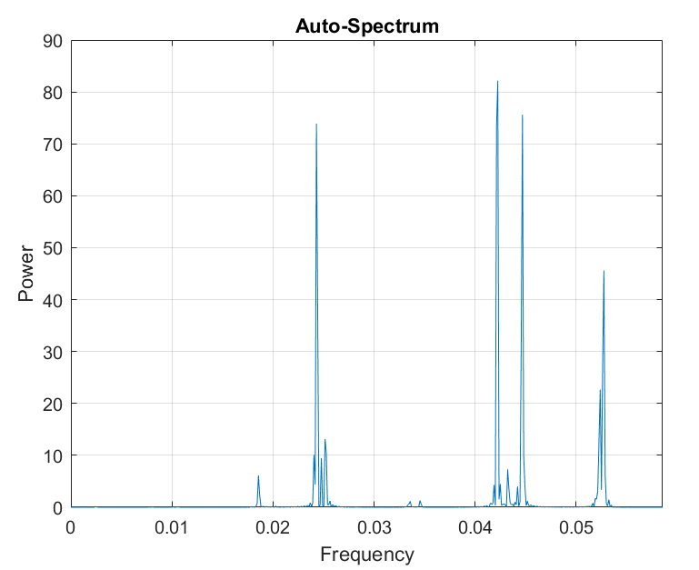

# Discussion and Conclusions

Using the first program we ran Blackman-Tukey and wavelet autospectral analysis on the calculated insolation data, and on the marine δO18 data. The calculated insolation data, shown in figure 2, revealed four peaks between frequencies of .02 and .055 (periods between 50 and 18), with the strongest (highest power) being just above .04 (25 period). The δO18 data showed two peaks at frequencies of 0.01 and 0.025, both with similar power. This allows for better understanding of the nature of the cycles. The wavelet spectral analysis shows changes in intensity of these of these frequency peaks over time, as shown in the color map plots of figure 3. This shows for example that there is less of a response to ocean temperature to the cycles for some reason around 2600-2700 kyrs at the two frequencies between 0.04-0.05, while the frequencies at ~0.25 are the opposite for the same period. This can give insight to some of the mechanistic causes of the paleoclimate.

Next, using the second program both datasets were run together through Cross spectral analysis, with the associated phase angle and coherence. Cross spectral analysis (see figure 4) showed two peaks, with coherence (similar to R2 correlation) of 0.73 and 0.80, respectively, or high coherence. The phase angle at those frequency is used to calculate the offset between oscillations, or the response period, in this case 313 and 199 kyrs. In other words, the ocean took about 200 and 300 kyrs to respond to the Milankovitch insolation that was reaching the earth.

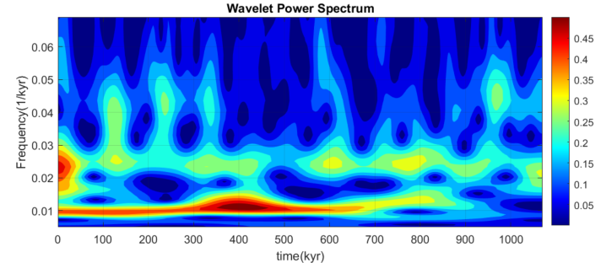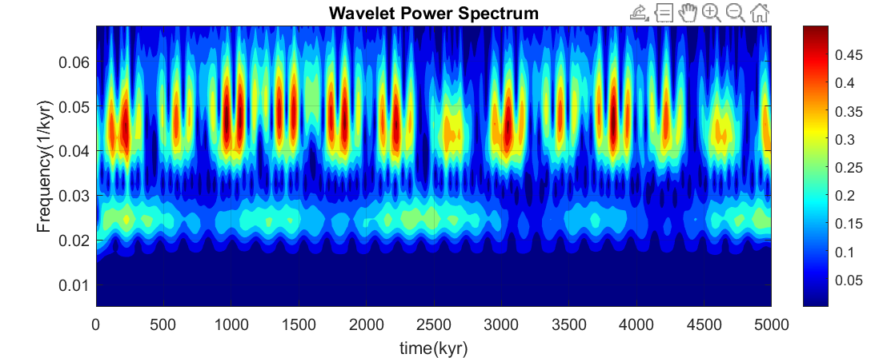

Figure 3. Wavelet spectral analysis of Insolation at 65 ° north latitude (bottom) and delta o 18 temperature proxy data (top). Warmer colors indicate higher power.

The two MATLAB functions that we wrote helped us to understand cycles more clearly in earth’s history by helping extract valuable data, such as periods of the cycle, the power of the cycle, and how genetically related time series relate to one another. This is invaluable to geologic studies like Milankovitch cycles and paleoclimate, especially when collecting data from vastly diferent environments, and correlating them to the bigger picture.

Figure 4. Cross spectral analysis, with associated coherence spectrum and phase spectrum. Phase spectrum indicates the shift, at the peak of interest, and coherence show the correlation of the cross spectral analysis.

